ECLC Relocation Sites & Evacuation Routes
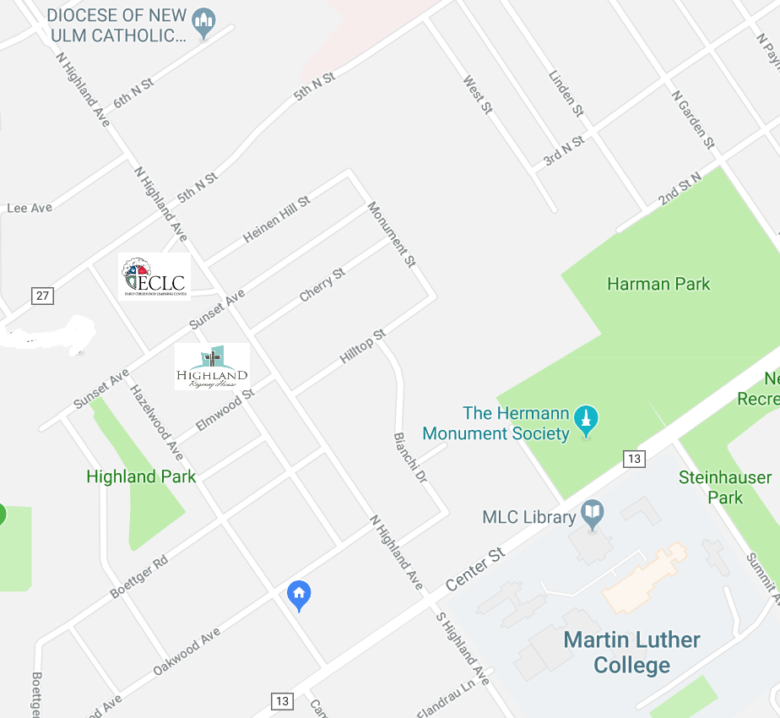
Location 3

Location 1

Location 2

Location 1 Highland Regency House
Location 2 New Ulm Diocese
Location 3 Martin Luther College Main Campus
Location 1

Location 3

